Standing Waves Experiment

Introduction
A string vibrator can be used to create a standing wave. If a sine wave generator is attached to the string vibrator, the frequency can be adjusted. By observation of the changes, you can reach a deeper understanding of the relationship between wavelength, frequency, and speed. By varying the weight (or tension) on the string, you can also make observations about how tension affects frequency, wavelength, and velocity.

Background
The string vibrator has several natural modes of vibration (see examples below). If the string is fixed at both ends, there is at least one node (a place with no amplitude) and at least one anti-node (place of maximum amplitude). The examples below show a ½ wavelength, 1 wavelength, 3/2 wavelength, and 2 wavelengths.

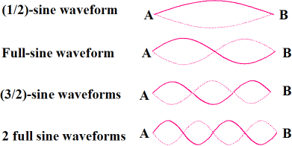

Experiment
Materials:
Sine Wave Generator
String Vibrator
Super Pulley
Clamps (2)
Red and black patch cords
Hanging Mass Set
Power Cord
Setup
See pictures below. Clamp a string vibrator to your surface. Make sure to clamp it hard enough to prevent movement but not so hard that it places undue pressure on the plastic housing. Then attach a second clamp to the surface approximately 1.5 meters from the string vibrator. Clamp the super pulley to the clamp as show below. Use the red and black patch cords to attach the string vibrator to the sine wave generator (both color cords are identical, so they can be mismatched). Then use the power cord to attach the sine wave generator to the outlet. Thread the string through the super pulley and then hang approximately 150 g from the string using the weights from the hanging mass set.
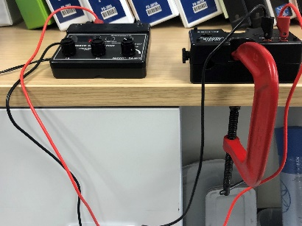
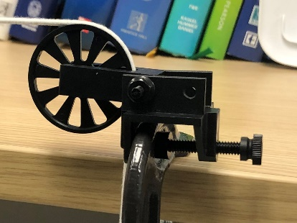

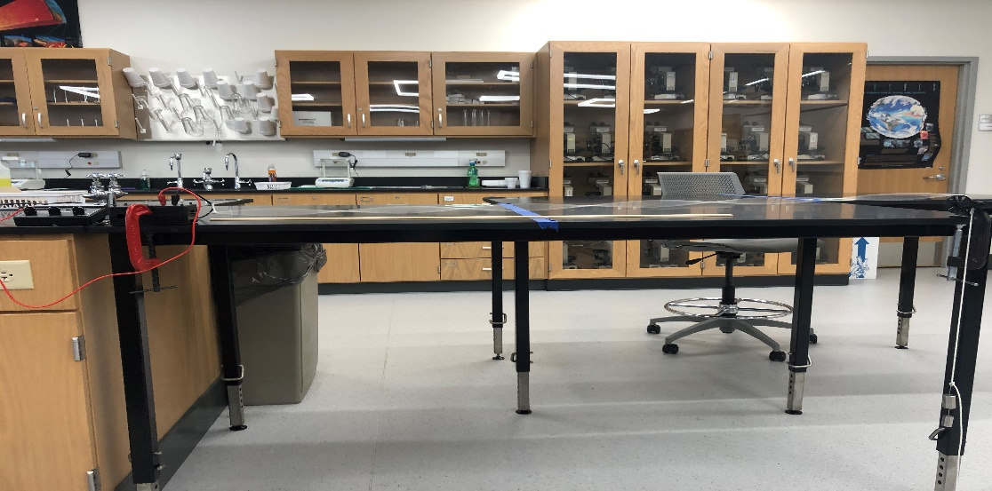

Part 1 Procedure
- Measure the distance from the knot where the string attaches to the string vibrator to the top of the pulley. This is your distance, L. It should be approximately 1.5 meters.
L=
- Turn on the Sine Wave Generator by plugging it in and turning the amplitude knob all the way down.
- Set the amplitude knob about halfway and use the coarse and fine adjusters to adjust the frequency so the string vibrates in four segments. Note: the point where the string attaches to the blade on the string vibrator should be a good node. A good node means you should NOT hear the string hitting the plastic housing.
- Measure the wavelength (one full cycle; in this case, two segments of the four) and record both the wavelength (λ) and the frequency (𝑓). Note that the wavelength should be measured in meters and the frequency in Hz. Record your data here and in Table 1.
λ= 𝑓=
How much can you change the frequency before you see an effect?

- Repeat steps 3 and 4 but make a standing wave with only two segments. Do not change the weight of the hanging masses. Record your data. You should be measuring one full cycle for the wavelength; in this case the whole string from knot to pulley.
How is the frequency of the two-segment wave related to the frequency of the four-segment wave? What is the ratio of these frequencies? Is this what you would expect?

With a two-segment wave, the length of the string, L, is one wavelength. Does it look like one wavelength?

Since the string vibrates up and down so fast, it is hard to see that when one side is up, the other is down. Try touching the string at an anti-node (an area with the highest amplitude). What happens?

Try touching the string at the central node? Can you hold the string at the node and not significantly affect the vibration?

Calculate the speed of the one-segment wave. Show your work! V=λ 𝑓

Calculate the speed of the two-segment wave. Show your work! V=λ 𝑓

How do these values compare? Are they about the same? Why or why not?

- Repeat steps 3 and 4 but make a standing wave with three segments. Do not change the weight of the hanging masses. Record your data. You should be measuring one full cycle for the wavelength; in this case, two of the three segments.
Calculate the speed of the three-segment wave. Show your work! V=λ 𝑓

Has the velocity changed?

Does the speed of the wave depend on the wavelength and velocity?

- Repeat steps 3 and 4 but make a standing wave with five segments. Do not change the weight of the hanging masses. Record your data. You should be measuring one full cycle for wavelength; in this case, two of the five segments.
Calculate the speed of the five-segment wave. Show your work! V=λ 𝑓

Has the velocity changed?

Does the speed of the wave depend on the wavelength and velocity?

- Now set the frequency to a value between the frequencies that produced waves of two and three segments. Adjust the frequency so that no particular standing waveform is present. Unclamp the string vibrator on the table and slowly move it towards the pulley. DO NOT release the string vibrator without clamping it to the table again. Without changing the frequency or the hanging masses, decrease the length of the vibrating string until it vibrates in two segments.
Measure the new wavelength and calculate the velocity. Show your work! V=λ 𝑓

Is it about the same as before?

Does the speed of the wave depend on the length of the string?

Data Table Part 1
Make sure that wavelength is recorded in meters (m) and frequency in Hz. Your velocity will then be in meters per second (m/s)
Number of Segments | Wavelength (λ) in m | Frequency (𝑓) in Hz | Wave Velocity (v) in m/s
2
3
4
5

Part 2 Procedure
- Clamp the String Vibrator back in its original position so that the total length, L, is the same. Now hang only 50 g from the string below the pulley.
- Adjust the frequency of the Sine Wave Generator so that the string vibrates in four segments. Record the frequency, wavelength, and mass in Date Table 2.
Note: for this part of the experiment, you will always adjust the frequency so that the wave vibrates in four segments.
- Add 50 grams to the hanging mass and repeat steps 1 and 2. Repeat at intervals of 50g up to 200g. Enter all your data in the Data Table Part 2.

Data Table Part 2
Tension (N)  N= mass (in kg) x 9.8 m/sec² | Wavelength (m) | Frequency (Hz) | Velocity (m/s)

Questions
- What factors affected the velocity of the waves in the string?

- What happens to the wavelength as the frequency increases?

- Which variable of v= λ 𝑓 is constant for the string?

- Does the tension (weight) on the string affect the frequency, wavelength, or velocity?

- What surprised you about this lab?

- What was the hardest part of the lab?

