Creating Accessible Documents
Becca Neel, University of Southern Indiana

☐ Headings
Why Use Pre-Defined Headings instead of Simple Text Formatting?
- Provide hierarchical structure to content in your documents
- Provide readers with audio and visual document navigation tools. Note: Keep track of your header levels as you work by enabling the Navigation Pane in the View menu in Microsoft Word.

Best Practices & Uses
- Should be sequentially ordered
- Can be repeated as necessary, with the exception of the title heading (usually H1)

☐ Bold & Italics
If you are looking to emphasize a particular word or phrase, or highlight an important bit of text:
- Use emphasis instead of italics
- Use strong instead of bold.

☐ Links
When possible, avoid including the full URL for websites and online resources in documents, presentations, emails, etc. Instead, use descriptive link text that makes sense when read apart from non-linked text.

Not-So-Great Example:
Click here for details regarding different disabilities reported by respondents in WebAIM’s 2017 survey of screen reader users. Learn more about screen reader users’ practices and preferences here: https://webaim.org/projects/screenreadersurvey7/

Much Better Example:
Embed the following URLs (or others!) with meaningful and descriptive text into a couple of sentences:
https://webaim.org/projects/screenreadersurvey7/#disabilitytypes
https://webaim.org/projects/screenreadersurvey7

☐ Lists
Always use the pre-formatted bulleted (unordered) or numbered (ordered) lists in a word processing, email, or presentation program.

☐ Images
Use alt text to
- Describe the purpose of, or meaningful content in an image
- Flag an image as strictly decorative
- Indicate an image is a logo

In Google Docs: Right click on image, select Alt Text
In MS Word: Right click on image, select Edit Alt Text. Or, right click on image, select Format Picture/Object> Layout & Properties > Alt Text.

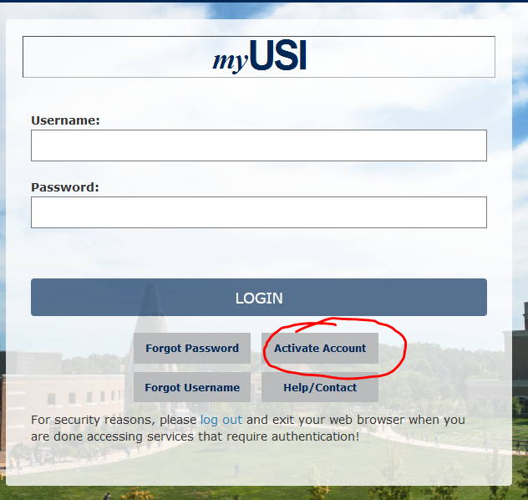

☐ Tables
- Make sure your table has a header row
- Include descriptive alt text for tables (just as with images). In Word, right click in table>Table Properties>Alt text.

Database Record Views – January 2019
Database | Record Views
CINAHL | 4301
JSTOR | 2430
ProQuest Central | 5394

Additional Resources
General Accessibility
- University of Minnesota: Accessible U
- Web Content Accessibility Guidelines (WCAG)
- WebAIM Accessibility Resources
- Yale Usability & Web Accessibility

Built-In or Open Source Screen Readers
- Apple VoiceOver Guide
- Microsoft Narrator (Built-In Screen Reader) Guide
- NVDA Download
Web Accessibility Plugins
- Spectrum Color Vision Deficiency Tester Plugin for Chrome
- Tota11y Accessibility Checker Plugin for Chrome Browser
- Tota11y Accessibility Checker Add-On for Firefox

