Snap Circuits Electricity Kit

Standard 4.PS.5 for 4th Grade

The exercises below can all be performed using the Snap Circuit Electricity Kits. Each group of students will need a Snap Circuits Electricity kit, a conductors and insulator bag, and a laminated sheet with additional projects. You can use the foam trays to make it easier for students to keep track of the pieces.

There are three elements necessary for a circuit to function: Voltage, Current, and Resistance. Imagine a circuit like a boat on a river. The current is the boat moving down the river. Voltage is the water carrying the boat downstream. Resistance is anything that slows down the boat-- plants, rocks, wind, etc.

- Closed Circuit

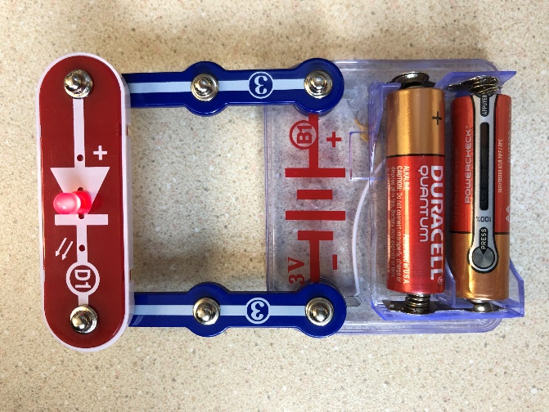

Students will need:
- 1 battery pack w/ 2 AA batteries (B1)
- 1 LED (D1). LED stands for Light Emitting Diode.
- 2 3-Snap Wires

Ask students to use the pieces given to make the LED light up. Have students discuss why they think the circuit they built works. Note that circuits flow from positive to negative. Students will notice that the D1 LED has to be positioned so that flow follows the positive to negative signs on both the battery and the diode itself. Students may wonder why they even need the 3 Snap Wires instead of placing the DI across the battery unit. The 3-Snap Wire provides a small amount of resistance. Too much current can actually damage the LED.

- Conductors and Insulators

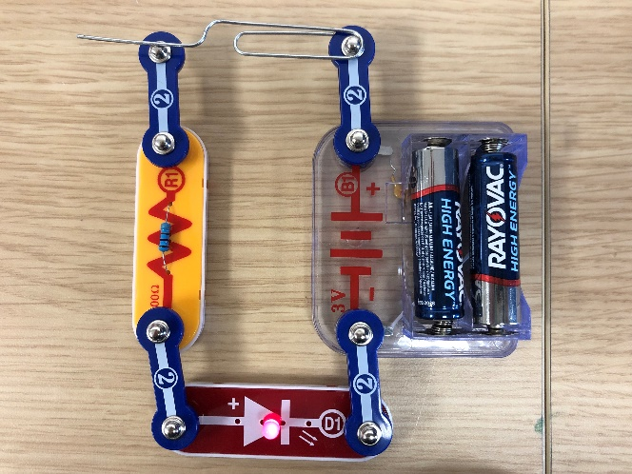

Students will need:
- The Conductor/Insulator Kit, which contains one
of each of the following. (feel free to add items from your classroom!):
  - Cotton bud
  - Popsicle stick
  - Paper clip
  - Plastic Lego piece
  - Copper wire
- Resistor (R1)
- LED (D1)
- 4 2-Snap Wires
- 1 Battery Pack with batteries (B1)

Have the students build Project #9 on the laminated sheet. Ask students to try holding each item across the opening in their circuits. Have them make a note of which ones make the LED light up and which ones do not. Ask them to hypothesize why some work but others do not.

The students have just studied resistance. Metal wires have some electrical resistance, but it is very low and can be ignored in almost all circuits. Materials, such as metals, which have very low resistance are called conductors. The best conductor material known of today is Silver, however because it is too expensive to be widely used, we use Copper instead. Copper is used in most wires and printed circuit boards in the electrical industry. Because of this low resistance, a conductor allows electricity to flow through the circuit.

Materials with high values of resistance, such as paper, plastic, and air, are called insulators. Insulators do not allow electricity to flow through the circuit. Most wires are insulated, which requires them to be stripped to expose the metal for them to be effective conductors.

- Parallel Circuit
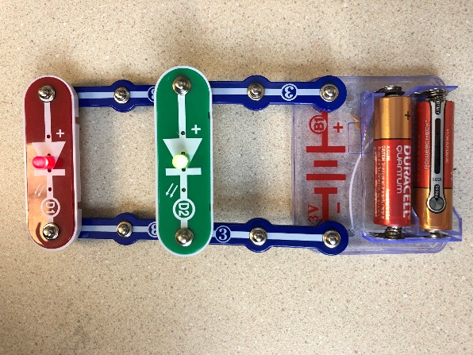
Students will need:
- 1 battery pack w/ 2 AA batteries (B1)
- 2 LED (D1 plus D2)
- Blue snap wires of multiple sizes (4 3-Snap Wires will work but students could use different combinations)

Ask students to use the pieces to make both LEDs light up at the same time. Have students hypothesize why some combinations work, but not others. Have them test what happens when either D1 or D2 is removed. The other should remain lit even after one is removed. Below is an actual electrical diagram of a parallel circuit:
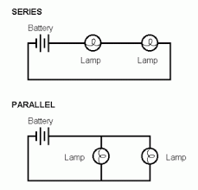

What the students have built is a parallel circuit. A parallel circuit is a type of circuit in which each leg (each path the circuit takes) is autonomous of the others. This means that if one LED were to stop working, the other would continue to function as normal. Much of the technology we see today uses a parallel circuit in some way. For example, most houses are wired in parallel; if one light fixture or outlet were to break, the rest of the power in the house still runs normally. Another example of this is newer (much less frustrating!) Christmas lights that continue to stay lit even when one bulb has died.

If you would like an additional activity to emphasize the concept of parallel circuits, try Project #6, Lamp and Fan in Parallel on the laminated sheet. Another great project is #153; it adds a switch to the parallel circuit.

- Series Circuit
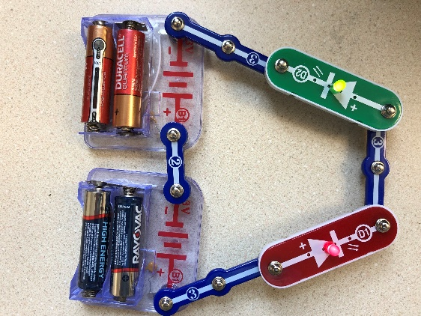
Students will need:
- 2 battery packs w/ 2 AA batteries (B1)
- 2 LED (D1 and D2)
- Blue snap wires of multiple sizes (need at least 4 different Snap Wires)

Ask the students to build a circuit with only 1 path that lights up both D1 and D2. It should be constructed so that if either D1 or D2 is removed, the circuit will no longer work. What the students have built is a series circuit. A series circuit is a type of circuit in which there is only one path for current to flow. This means all parts of the circuit must be fully operational for the circuit to work. An example of a series circuit in everyday life is most house lamps. All pieces of a lamp (lightbulb, contacts, wiring) must be in working order for the lamp to turn on.

- Students may wonder why two battery packs are required when the parallel circuit only required one. Have them try it with one battery pack and see if it works if the question has not been asked. In a parallel circuit all branching paths, or “legs”, of the circuit are autonomous, meaning they function individually from one another. Because of this, the voltage (the pushing force) remains the same throughout all paths of the circuit. In a series circuit, there’s only one path, meaning that there is a voltage drop through each device in the circuit. Using one battery pack in a series circuit does not provide enough voltage, so two must be used to ensure that there is enough voltage for both LEDs to function. This is a tough concept—don’t let the students get hung up on it.

Have the students try Project #5 on the laminated sheet. It shows a lamp and fan in series. Project #152 is another example of Series Circuits.

- Using Resistors

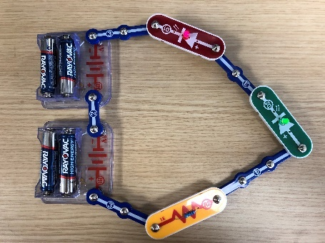

Students will need:
      - 2 battery pack w/ 2 AA batteries (B1)
      - 2 LED (D1 plus D2)
      - Blue snap wires of multiple sizes (4 3-Snap Wires will work but students could use different combinations)
      - Resistor (R2)

A resistor is an electrical device that restricts the passage of electrical current. In some circuits, like the ones built using a Snap Circuits kit, a resistor is not necessary, but it does have obvious effects. In other circuits, such as the chips and boards found in phones or TVs, resistors are a crucial component of the circuit and the device would be damaged if the resistor was removed. Resistance is measured in ohms—the upside down U looking figure on the R circuits is the symbol for Ohms.

Have students begin with a 2 LED series circuit. Have students use a 1K ohm (R2) and allow them time to observe what happens when it is introduced to the circuit. (both bulbs should get noticeably lighter). See picture. Once students have done so, encourage them to try adding a second resistor at various places in the circuit.

Questions for your students:
- What happens when the resistor is put into this circuit?
- Does it matter where I put the resistor in this circuit?
- What is the resistor actually doing?

Have students take apart the series circuit and build a parallel circuit. Have students take a resistor (any R circuit) and allow them time to observe what happens when it is introduced to the circuit. Once students have done so, encourage them to adding a second resistor into the circuit.
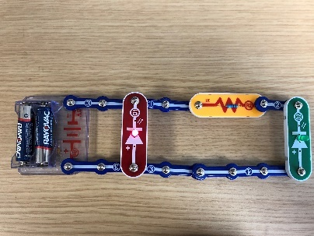

Student Questions:
- What happens when you put a resistor in the first path of the circuit? What about the second? (the resistor should only work on one circuit)
- What are some of the key differences between the series and parallel circuit resistance? Why do you think the type of circuit affects the resistance? (in a parallel circuit, the resistor will only affect the LED in the circuit with the resistor)

