Teaching about Circuits with Vernier Circuit Board

Standard 4.PS.5 for 4th Grade

The exercises below can all be performed using the Vernier Circuit Board kit. Each group of students will need a Vernier Circuit Board kit. Each kit contains light bulbs, a basic circuit board, and alligator clips of various colors.

Note: all alligator clips are the same regardless of color. The color simply helps the user track the wires.

There are three elements necessary for a circuit to function: Voltage, Current, and Resistance. Imagine a circuit like a boat on the river. The current is the boat moving down the river. Voltage is the water carrying the boat downstream. Resistance is anything that slows down the boat-- plants, rocks, wind, etc.

- Closed Circuit

Students will need:
- 2 D batteries
- 1 miniature lightbulb (found in kit)
- 2 wires/ clips—any color

Ask students to use the pieces given to make the bulb light up. Have students discuss why they think the circuit they built works. Note that circuits flow from positive to negative. The positive end of the battery is connector #1 and is found at the upper right-hand side of the battery box. The negative end of the battery is found in the middle of the board near the bottom and is labeled #35.

Answer:
Connect one end of the first wire to the positive battery terminal (1) and the other end to one side of the lightbulb (either 26 or 27). Connect one end of the second wire to negative battery terminal (35) and connect the other end to the open end of the lightbulb (either 26 or 27). The bulb should light up! Have the students remove just one clip to demonstrate the need for the circuit to be closed in order to light up the bulb.

- Conductors and Insulators

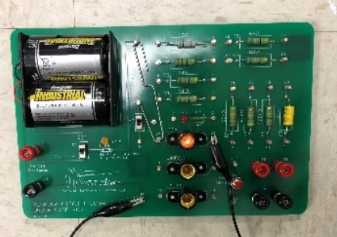

Students will need:
- The Conductor/Insulator Kit, which contains one
of each of the following. (feel free to add items from your classroom!):
  - Popsicle stick
  - Paper clip
  - Plastic Lego piece
  - Copper wire
- 1 miniature lightbulb (found in kit)
- 1 wire
- 2 D batteries

Have the students connect one end of a wire to negative battery terminal (35) and connect the other end to the open end of the lightbulb (27). Ask students to try holding each item across the opening in their circuits (connecting terminal 1 to terminal 26) *Note: students will have to unfold and refold the paperclip for it to stay in place like the picture*. Have them make a note of which ones make the bulb light up and which ones do not. Ask them to hypothesize why some work but others do not.

The students have just studied resistance. Metal wires have some electrical resistance, but it is very low and can be ignored in almost all circuits. Materials, such as metals, which have very low resistance are called conductors. The best conductor material is silver; however because of cost, we use copper instead. Copper is used in most wires and printed circuit boards in the electrical industry. Because of this low resistance, a conductor allows electricity to flow through the circuit.

Materials with high values of resistance, such as paper, plastic, and air, are called insulators. Insulators do not allow electricity to flow through the circuit. Most wires are insulated, which requires them to be stripped to expose the metal for them to be effective conductors.

- Parallel Circuit
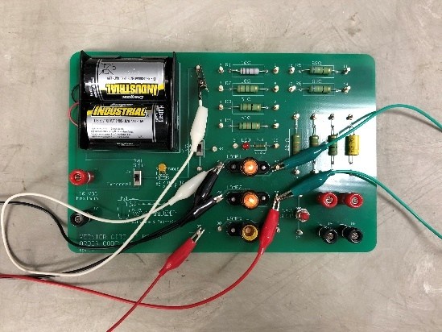

Students will need:
- 2 D batteries
- 2 miniature lightbulbs (found in kit)
- 4 wires

Have the students insert light bulbs into Lamps 1 and 2. Ask students to use the pieces make both bulbs light up at the same time. Have students hypothesize why some combinations work, but not others. Have them carefully unscrew one lightbulb from the circuit. The other should remain lit even after one is removed. Below is an actual electrical diagram of a parallel circuit:
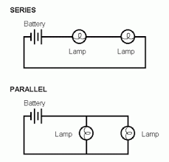

What the students have built is a parallel circuit. A parallel circuit is a type of circuit in which each leg (each path the circuit takes) is autonomous of the others. This means that if one light bulb were to stop working, the other would continue to function as normal. Much of the technology we see today uses a parallel circuit in some way. For example, most houses are wired in parallel; if one light fixture or outlet were to break, the rest of the power in the house still runs normally. Another example of this is newer (much less frustrating!) Christmas lights that continue to stay lit even when bulb has died.

Answer:
Attach one end of a wire to the positive battery terminal (1), then attach the other end to the nearest lightbulb terminal (26). Next, attach a new wire to the same lightbulb terminal (26) and connect the end to the next lightbulb terminal (28). Then, attach one end of a third wire to the opposite terminal of the first lightbulb (27) and the other end to the opposite of the second lightbulb (29). Finally, connect the fourth wire to the previously mentioned terminal (29) and connect the other end to the negative battery terminal (35).

- Series Circuit
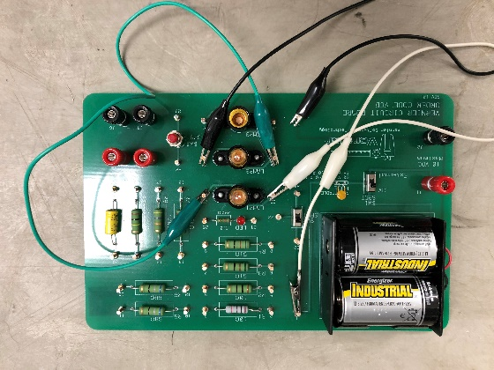

Students will need:
- 2 D batteries
- 2 miniature lightbulbs (found in kit)
- 3 wires

Have the students insert lightbulbs into Lamps 1 and 2. Ask the students to build a circuit with only 1 path that lights up both lightbulbs. It should be constructed so that if either bulb is removed, the circuit will no longer work. What the students have built is a series circuit. A series circuit is a type of circuit in which there is only one path for current to flow. This means all parts of the circuit must be fully operational in order for the circuit to work. An example of a series circuit in everyday life is most house lamps. All pieces of a lamp (lightbulb, contacts, wiring) must be in working order for the lamp to turn on.

- Students may wonder why the lightbulbs are dimmer than they were in the parallel circuit. In a parallel circuit all branching paths, or “legs”, of the circuit are autonomous, meaning they function individually from one another. Because of this, the voltage (the pushing force) remains the same throughout all paths of the circuit. In a series circuit, there’s only one path, meaning that there is a voltage drop through each device in the circuit. Using a series circuit does not provide as much voltage to each lightbulb, so they are dimmer than a parallel circuit. This is a tough concept—don’t let the students get hung up on it.

Answer:
Attach one end of a wire to the positive battery terminal (1), then attach the other end to
the nearest lightbulb terminal (26). Attach the first end of the second wire to the opposite lightbulb terminal (27) and the second end to the new lightbulb terminal (28). Finally, attach the end of the third wire to the opposite terminal of the new lightbulb (29) and the other end to the negative battery terminal (35).

- Using Resistors

Students will need:
      - 2 D batteries
      - 1 miniature lightbulb (found in kit)
      - 3 wires

A resistor is an electrical device that restricts the passage of electrical current. In some circuits, like the ones built using a Vernier circuit board kit, a resistor is not necessary, but it does have obvious effects. In other circuits, such as the chips and boards found in phones or TVs, resistors are a crucial component of the circuit and the device would be damaged if the resistor was removed. Resistance is measured in ohms—the upside down U looking figure on the board next to the resistors is the symbol for Ohms.

Students should place one bulb in Lamp 1. Have students begin by placing one wire connecting the terminal of the lightbulb (26) to the negative battery terminal (35), this wire will stay in place. Take a second wire and connect it to the positive battery terminal (1) and the R1 resistor terminal (2), this wire will also stay in place. Take the third wire and connect one end of it to the opposite lightbulb terminal (27). To examine the effects of the resistor, have the student hold the loose end of the third wire (Careful- make sure to hold it over the rubber insulation!) and touch the metal tip to the positive battery terminal (1), then to the end of the opposite resistor terminal (3). Have students note any changes in the circuit, particularly in the lightbulb.

Questions for your students:
- What happens when the resistor is put into this circuit?
- Does it matter where I put the resistor in this circuit?
- What is the resistor actually doing?

