Easy Lessons with the Basic Electricity Kit
This kit is designed to teach students about basic electricity. Using the equipment provided, you can teach concepts like:
- Circuits
- Conductors v. insulators
- Series and parallel circuits
- Resistors
There are enough materials in each kit to make 6 student stations.
Lesson #1: Basic Circuit
Each station needs: 1 battery cell, 1 light bulb, 1 light bulb holder, 2 leads of any color.

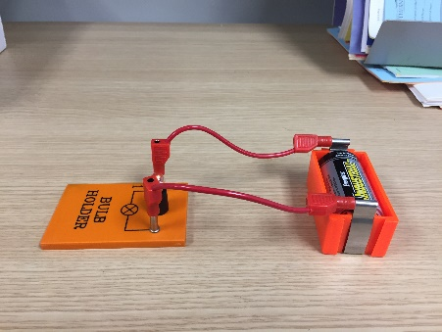
The goal of this lesson is to teach about a basic circuit. The bulb will only light up when the circuit is completed. Have students remove even just one end of the leads to demonstrate how a circuit works. The circuit must be unbroken for the light bulb to work.

Lesson #2: Changing Light Intensity by Increasing Power
Each station needs: 2 battery cells, 1 light bulb, 1 light bulb holder, 2 leads of any color

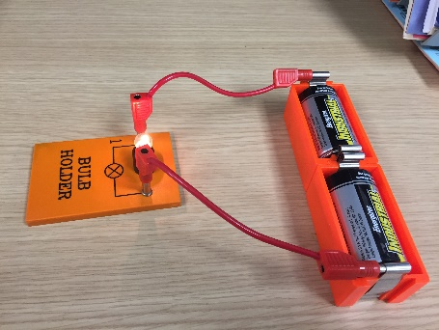
The goal of this lesson is to demonstrate the change in light intensity when power is increased. Have the students observe light intensity with 1 battery cell, and then have them add a second power source with another battery cell. They should notice that the light intensity has increased. They can combine groups and even add a third cell if desired!

Lesson #3: Creating a Temporary Circuit Break with a Push Switch
Each station needs: 1 battery cell, 1 light bulb, 1 light bulb holder, 1 push switch, and 3 leads of any color.

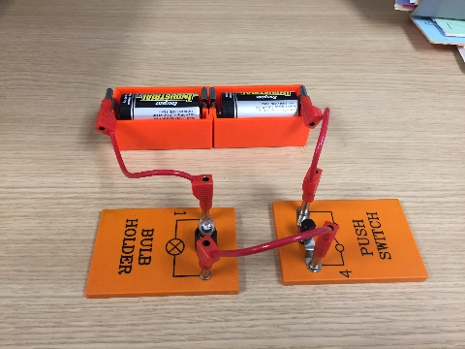
The goal of this lesson is to demonstrate how power can be saved with a push switch. Similar to a light switch, the students should observe that the bulb only lights up when the push switch is depressed. When in the open position, the circuit is not completed and bulb does not light up. Note: the experiment can be done using either 1 or 2 battery cells.

Lesson #4: Creating a Series Circuit
Each station needs: 1 battery cell, 2 light bulbs, 2 light bulb holders, and 4 leads of any color.
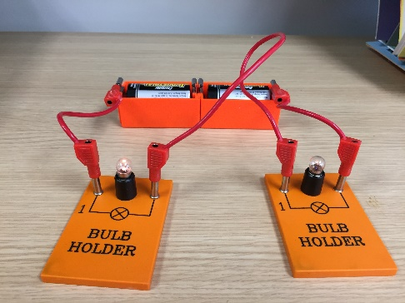
The goal of this lesson is to introduce the concept of a series circuit. Have the students disconnect one of the leads to a bulb holder and notice that neither bulb lights up. Because the circuit has been broken, neither light bulb illuminates. Note: the experiment can be done with either 1 or 2 battery cells. The experiment can also be done without the push switch if desired.

Lesson #5: Creating a Parallel Circuit
Each station needs: 1 battery cell, 2 light bulbs, 2 light bulb holders, and 4 leads of any color.

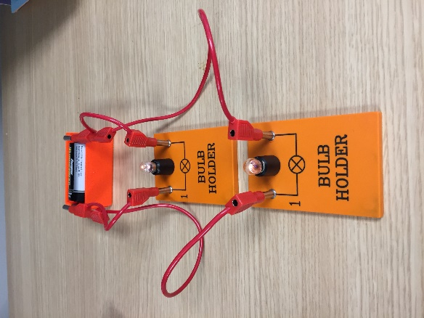
The goal of this lesson is for students to understand the difference between parallel and series circuits. Make sure the students remove the lead from one of the bulbs and observe that the other bulb still stays illuminated.

Lesson #6: Using Resistance
Each station needs 1 battery cell, 1 light bulb, 1 light bulb holder, 1 Rheostat, and 4 leads of any color.

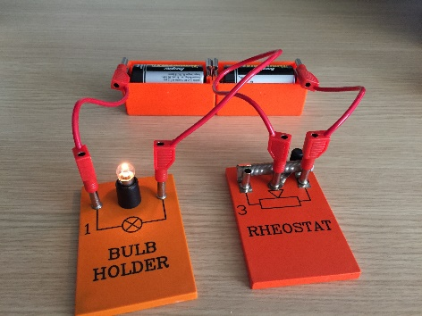
A Rheostat is a variable resistor. It creates electrical resistance, making it harder for electricity to flow. This is the same principle used in dimmer switches on lights. Using less power can save money or allow a device to operate at a more optimal level (another example is a motor). Make sure the students test the switch on the Rheostat so they can see the intensity of the light change! Note: students may need to use 2 battery cells.

Lesson #7: Conductors and Insulators
Each station needs 1 battery cell, 1 light bulb, 1 light bulb holder, 1 universal clip, and materials to test. Included in the kit are plastic legos, carbon rods, copper sheet, steel rods, and wood (pencil)

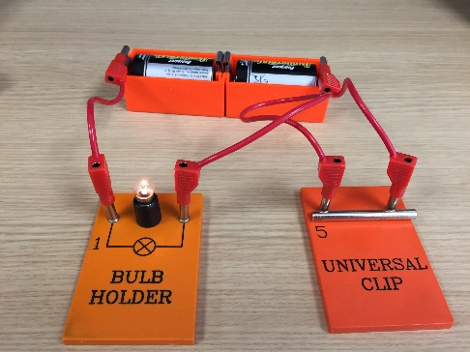
The object of this lesson is to introduce students to the differences between conductors and insulators. The Universal Clip allows students to see if a material is a conductor (able to conduct electricity) or an insulator (not able to conduct electricity). Make sure the object to be tested is in contact with both bars on the Universal Clip. Have the students test the materials and included and maybe even other items in your classroom!

There are many more experiments you can do with your students using the other equipment in the box. These experiments are just designed to get you and your students started!!!

