

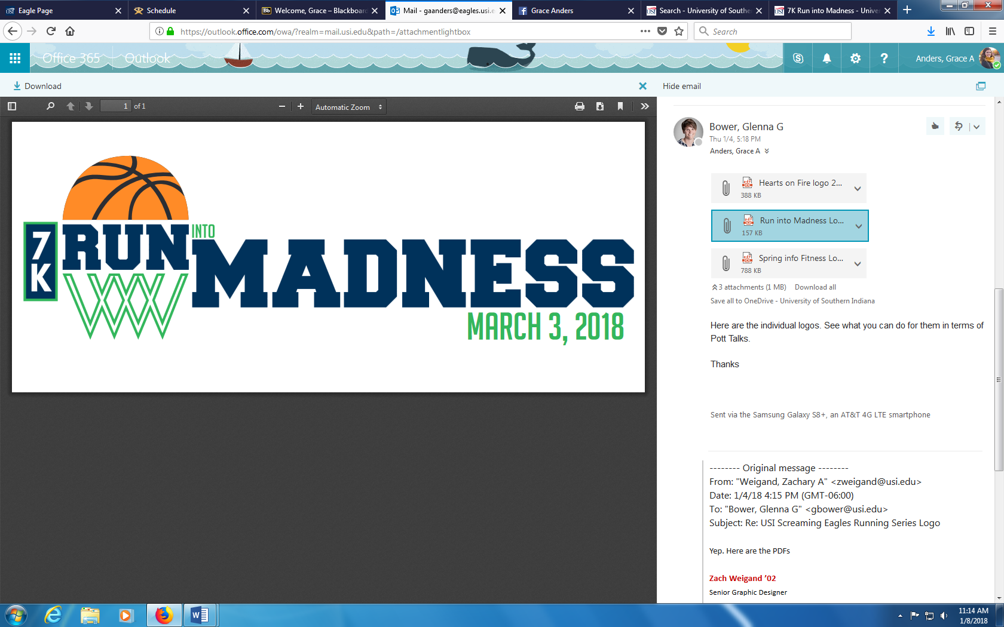

* Come join the third annual **Run into Madness 7K**! This event features and athlete division Run/Walk on Saturday, March 3 2018 starting at 9 a.m.
* This event is one of the three Screaming Eagles Running Series races [Hearts on Fire 5K in February and Spring into Fitness 10K in April].
* The focus of this series is to increase the health and well-being of the Evansville community while also providing hands-on experience for students at the University of Southern Indiana.
* A portion of the proceeds from the Run into Madness 7K will be used to offer programming and provide professional development opportunities for student clubs within USI’s Pott College.

|  |  |
| --- | --- |
| **Registration** | **Cost** |
| Register by February 24th | $20 |
| Register after February 24th | $25 |
| Register by February 6th  *[all three running series races]* | $55 |

* Go to **usi.edu/running** for more information and to get registered.