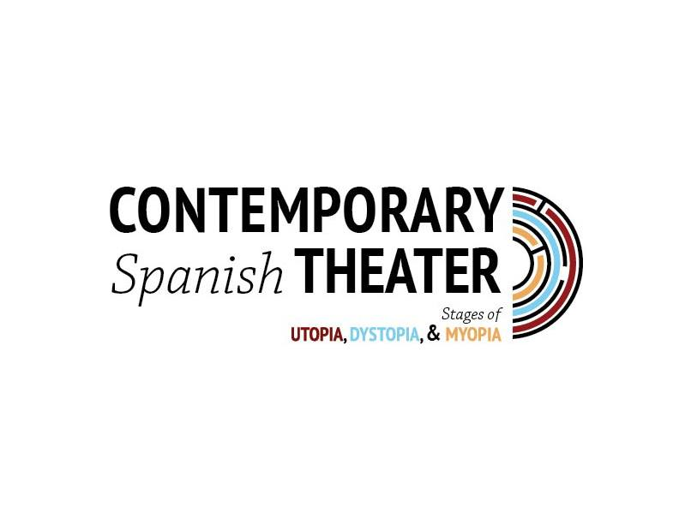
REGISTRATION FORM (FOR ALL PARTICIPANTS TO PRINT AND MAIL/EMAIL TO ADDRESSES SHOWN BELOW)
Registration Deadline: August 1st, 2018
New Harmony International Conference on Contemporary Spanish Theater: Stages of Utopia, Dystopia and Myopia. October 10-12, 2018
NAME: ______________________________________________________________________
PRESENTATION TITLE (IF APPLICABLE): ____________________________________________
ACADEMIC TITLE: _____________________________________________________________
INSTITUTION: ________________________________________________________________
ADDRESS: ___________________________________________________________________
CITY: _______________________________________________________________________
COUNTRY: __________________________________________________________________
EMAIL: ____________________________________________________________________
REGISTRATION FEES:
PRESENTERS
○ Faculty Presenter (College/University Level) $275
○ M.A. or Doctoral Student Presenter $150
○ Retirees $50
Included in presenter registration:
Daily lunch in New Harmony (Oct. 10-12), Banquet Dinner at USI (Oct. 11), Dinner at New Harmony Inn (Oct. 12)

NON-PRESENTERS
○ Non-Presenter Attendee (no meals) $0
Non-Presenter Attendee with meals (Indicate all that apply)
○ Wednesday lunch $10
○ Thursday lunch $10
○ Thursday banquet $16
○ Friday lunch $10
○ Friday dinner $25

PLEASE NOTE THAT ADMISSION TO ALL THEATRICAL PERFORMANCES AND SCHOLARLY PRESENTATIONS IS FREE TO ALL REGISTERED GUESTS AND MEMBERS OF THE PUBLIC.
TOTAL DUE: ________________
IF USING A PERSONAL CHECK, MAKE PAYABLE TO UNIVERSITY OF SOUTHERN INDIANA AND SEND TO THE MAILING ADDRESS BELOW.
**FOR ALL CONFERENCE PARTICIPANTS, PLEASE PRINT THIS COMPLETED FORM AND SEND VIA SNAIL MAIL OR EMAIL
MAILING ADDRESS:  OUTREACH AND ENGAGEMENT  UNIVERSITY OF SOUTHERN INDIANA  8600 UNIVERSITY BLVD.  EVANSVILLE, IN 47712 | EMAIL:  aawatson@usi.edu

