
Kitch & Schreiber Internship Position: NYBA Director/Sports Marketing Intern

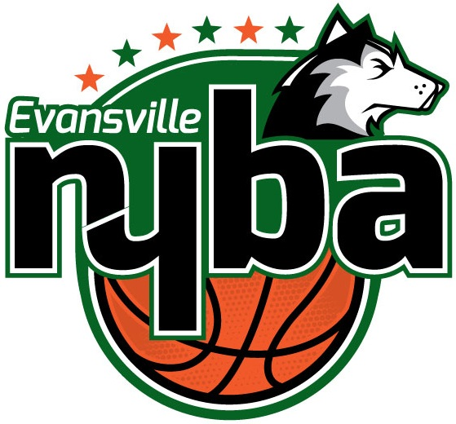
The Evansville North Youth Basketball Association Director works closely with North High School Athletics Department including Boys and Girls Coaches, North District school Principals and other staff members (North High School, North Junior High School, Delaware Elementary, Evans Elementary, Oak Hill Elementary, Scott Elementary and Vogel elementary) to plan and execute NYBA instructional/recreational basketball league activities.

Additionally, the intern will assist Kitch & Schreiber Marketing & Advertising with sports marketing initiatives, including marketing and advertising of local professional and amateur sports events and teams, including golf, baseball, basketball and more.

Commitment: September 4, 2017 – January 28, 2018
Part-Time: 15 Hours Weekly
Salary: $8.00/Hour

NYBA Responsibilities:
- Promote and advocate NYBA and youth sports; build participation; oversee registration
- Oversee financial well-being of NYBA organization
- Communications with parents, coaches and school personnel
- Oversee website, email marketing and social media
- Secure and schedule gym and facility usage
- Coordinate practice and game schedules
- Recruit, select and oversee volunteers including coaches and assistant coaches
- Oversee referee scheduling
- Equipment, uniform and supplies procurement and distribution
- Develop, refine and enforce rules
- Direct end of season tournament
- Maintain 501(c)(3) non-profit organization status

Kitch & Schreiber Responsibilities:
- Assist in day-to-day operations of advertising agency, with a focus on sports marketing initiatives
- Marketing strategy for local sports events and teams
- Advertising planning and execution
- Website, social media and email marketing coordination

To apply, send resume and cover letter to rhett@kitchandschreiber.com. Call 812-204-7561 with inquiries.

