GLOBAL PREM ER SOCCER
GPS

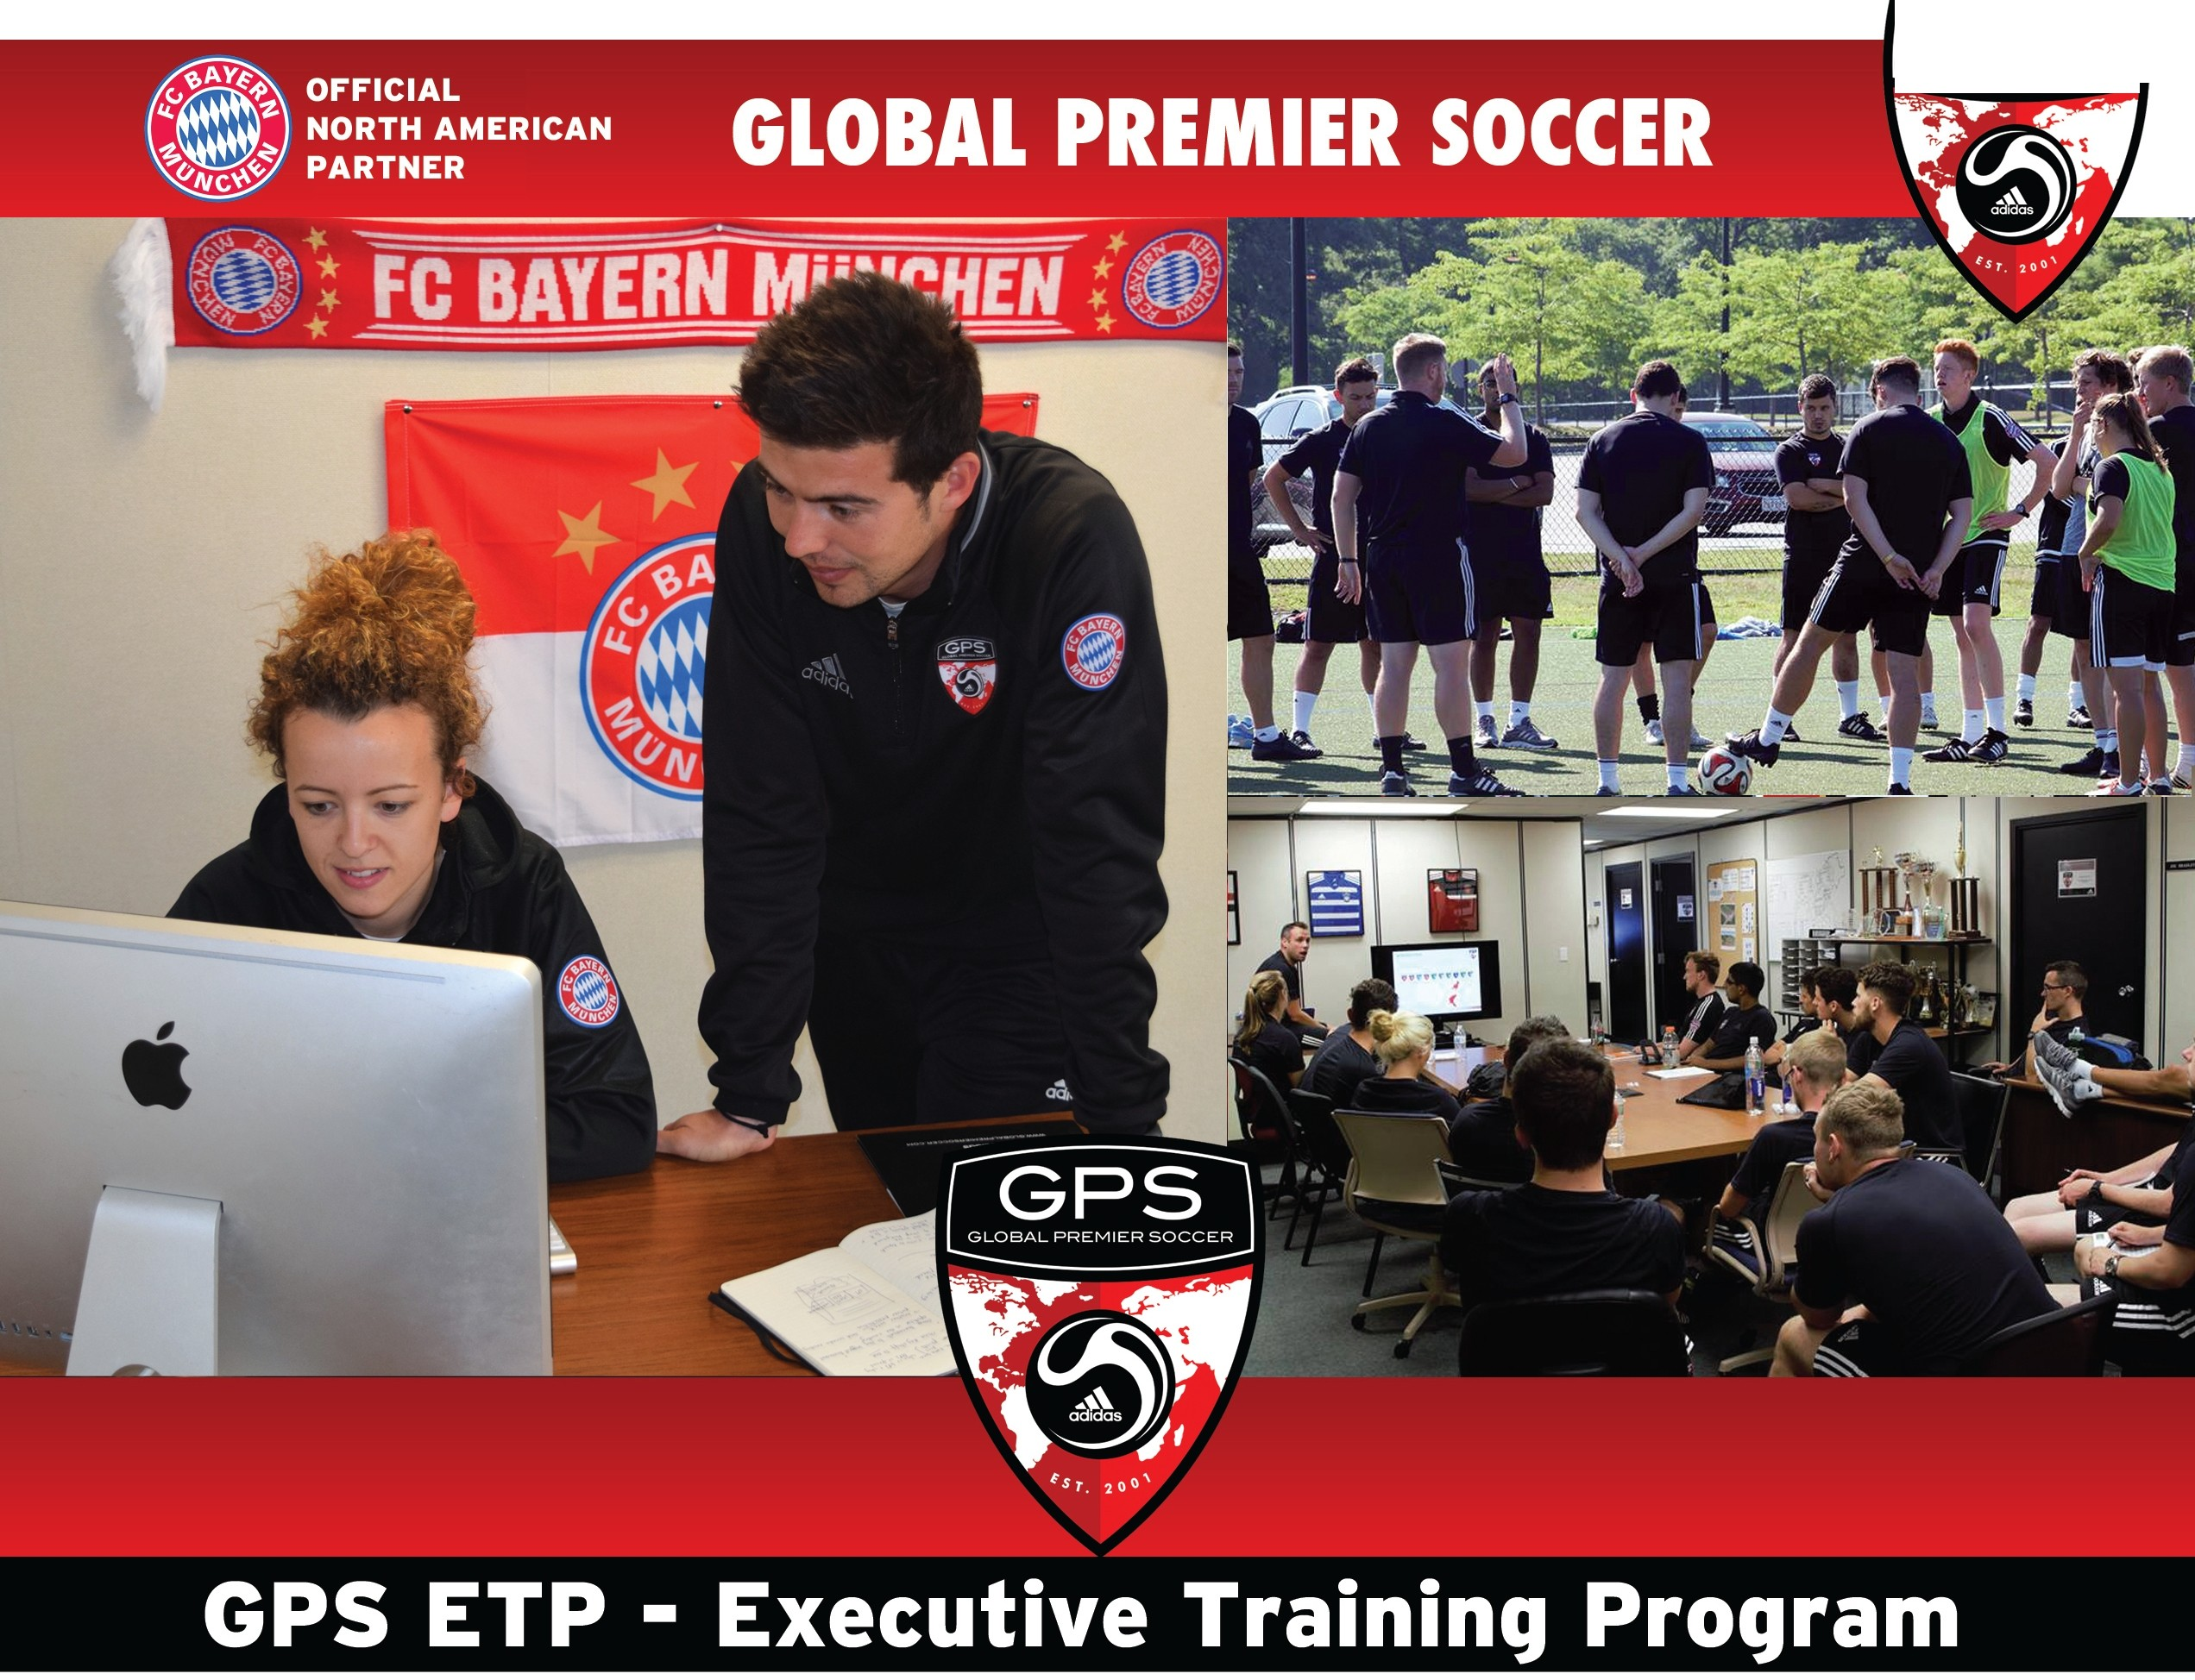
• Global Premier Soccer is one of the biggest and fastest growing soccer companies in the US.
• Market-leading Organization active in 21 States. Exclusive North American Partner of German Giants, FC Bayern Munich.
• Hands-on training in any one of the 13 GPS departments, including: Marketing, Sales, Graphic Design,
Program Management, Finance/Player Accounts, Human Resources, Camps & Vacation programs, Leagues
& Tournaments, GPS Foundation, Town Partner program, Operations, Technical and Premier.
• Trainees will be active in GPS Coaching {previous experience necessary}.
• 1 0 month program, compensation package includes transport and a weekly stipend. Accommodations are available if needed.

Please send your CV/Resume to Phillip Mitchell Email: pmitchell@globalpremiersoccer.com Phone: 781-891-6900 ext. 27

GLOBALPREMIERSOCCER.NET/CAREERS

What is the ETP?

The GPS Executive Training Program is designed to provide college graduates from leading Sports Management programs with the experience necessary to progress their careers in the highly competitive field of Sports Management.

This is not an educational qualification but is rather a hands-on opportunity to gain practical experience that will enhance your future career trajectory.

What is included in the Program?

The GPS Executive Training Program will
begin with an off-site 3 day Training Event at
the Foxwoods Resort in Connecticut in
mid-August followed by a week-long Induction
at GPS HQ in Massachusetts.

Hands-on training in any one of the 13 GPS departments, including: Marketing, Sales, Graphic Design, Program Management, Finance/Player Accounts, Human
Resources, Camps & Vacation programs, Leagues & Tournaments, GPS Foundation, Town Partner program, Operations, Technical and Premier.

What is the duration of the program?

This is a 10 month program beginning
mid- August and ending mid-July with a month
off from mid-December to mid-January.

What level of soccer experience do I need?

Soccer coaching and/or soccer playing experience is required as Trainees will be on the field coaching regularly as part of this program. The variety of coaching roles is extensive with age groups ranging from 4 year old GPS Juniors to 8 year olds in our Early Development Program, all the way to high level teenage players in our Premier Program with aspirations of playing College soccer.

Minimum requirement would be at least
having played High School soccer or 1 season of soccer coaching experience at any level. Most importantly, if you have the energy, enthusiasm and patience to coach, you will be successful in the on-field component of this program. Detailed curriculum support is provided along with regular on field coach development training.

The program will be 2/3 sports management office based work and 1/3 on field coaching and professional development.

Is there a cost to the program? Is this a paid opportunity?

There is no cost to the program and in fact it is a paid position. Compensation package includes a weekly stipend and transport. Accommodations are available if needed.

What are the prerequisites? How do I apply for this program?

We are looking for energetic and ambitious graduates with a degree in Sports Management. As above, soccer coaching and/ or soccer playing experience is required as Trainees will be on the field coaching regularly as part of this program.

To apply for this program please send your resume to Phil Mitchell at pmitchell@globalpremiersoccer.com

What opportunities will this create for me?

All successful graduates will experience an intensive development and training experience that will establish a great starting point for a successful career in Sports Management. The strongest graduates will be offered full-time positions with GPS.

At a minimum this program will have a significant impact on strengthening your resume and will provide invaluable experience and a network for future opportunities.

GPS is proud of the staff members it has already moved on to Sports Management positions at organizations including the San Jose Clash, New England Revolution, Boston Breakers, NJ Sky Blue, Chelsea Hong Kong and the Irish FA.

Are there opportunities still available this year?

Yes!

Contact Phil Mitchell immediately at
pmitchell@globalpremiersoccer.com

