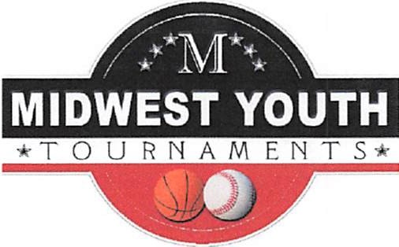

Internship Description

Midwest Youth Tournaments has had great success over the years in holding leagues and tournaments in both basketball and baseball. It is our philosophy that each league and tournament must first and foremost be a great experience for players, coaches, parents and fans. Individuals that are selected to represent Midwest Youth Tournaments must also embrace this philosophy with an understanding that our endeavors are as much a part ofthe entertainment
industry as the sports industry. Each person that attends our events (player, coach, parent or fan) is a customer, and should be treated as such. Our constant goal is to Exceed Customer Expectations.

I. Position Description

A. Skills Required

l. Excellent communication skills.
2. Ability to network in order to secure contacts for leagues and tournaments.
3. Ability to present league and tournament information in a phone conversation.
4. Highly organized.
5. Basic computer skills. Ability to communicate via. E-mail. Understanding of
Microsoft Word and Excel.
6. Negotiation Skills
7. Basic accounting skills
8. Skilled in conflict resolution.
9. Flexible
l 0. Extremely honest

B. Duties and Responsibilities

l. Contact teams to form leagues and tournaments.
2. Produce schedules and communicate to teams in timely fashion.
3. Post league and tournament schedules on website.
4. Post results of leagues and tournaments on website.
5. Secure and organize required staffing for leagues and tournaments.
6. Consistent, on-going communication with coaches I team contacts.
7. Maintain accurate records of all league and tournament financial results.
8. Maintain a database of contacts by age/grade and gender.
9. Oversee and supervise tournaments.
10. Order award products and assemble awards for tournaments.
11. Order T-shirt products and fabricate the tournament T-shirts.
12. Intern will sign a "No-Compete" contract.

n. Midwest Youth Tournaments Agreement

A. Share contact information and leads to support Intern in securing teams for leagues and tournaments.

B. Train and support Intern in scheduling process.

C. Provide assistance with manpower to run events when physically possible.

D. Provide marketing support with a professional website, brochures, registration forms, etc.

E. Tournament Expenses such as referee fees, rental, etc. will be paid by Midwest Youth
Tournaments.

Midwest Youth Tournaments
Midwestyouthtournaments.com
Contact is Chuck Hensley, Owner
17 Connor Ct.
Bedford, IN 47421
812-797-4024

