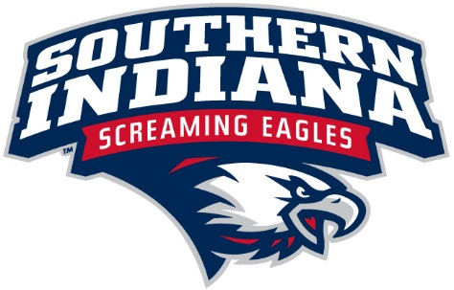

The University of Southern Indiana is seeking a Graduate Assistant (GA) for NCAA Compliance in the Department of Athletics. The GA position is a paid, 9-month (August-May), renewable annually, part-time position, which is eligible for a tuition and fees plus paid an hourly wage.

Responsibilities
- Assist with the development and maintenance of protocols for monitoring compliance with NCAA, conference and university rules and regulations
- Discussion and analysis of initial, two-year transfer and four-year transfer eligibility decisions
- Assisting with planning compliance education sessions for various groups
- Assist with various game day responsibilities
- Other duties as assigned

Requirements
- Bachelor’s degree required
- Must be able to work some USI home athletic events (nights and weekends)
- Candidate must have strong written and verbal skills and be extremely familiar with Microsoft Outlook, Word, Excel and Powerpoint.
- Must be able to work in a team environment and review and recommend improvements to the processes.
- Ability to complete administrative paperwork.
- Ability to use independent judgment.
- Organizing and coordinating skills.

As an individual employed in an administrative capacity in the athletics department, you are subject to the regulations of the NCAA. If at any time it is determined that you are in violation of such regulations, then by the provision of the NCAA enforcement procedures, you may be subject to corrective disciplinary action, up to and including termination of employment.

If interested, please send a cover letter and resume to Assistant Athletic Director, Mandi Fulton, via email at mfulton@usi.edu. The deadline to apply is April 1, 2016. Candidates may be brought in for interviews prior to the deadline, but no decisions will be made until after.

Candidate must get accepted into a USI graduate program. Information on graduate programs can be found at https://www.usi.edu/graduatestudies.

