Sine Wave Generator/String Vibrator Laboratory Activity

Materials Key Terms
Sine Wave Generator Wavelength
String Vibrator Amplitude
Ring Stand Frequency
2 Patch Cords Wave
Pencil Crest
Trough
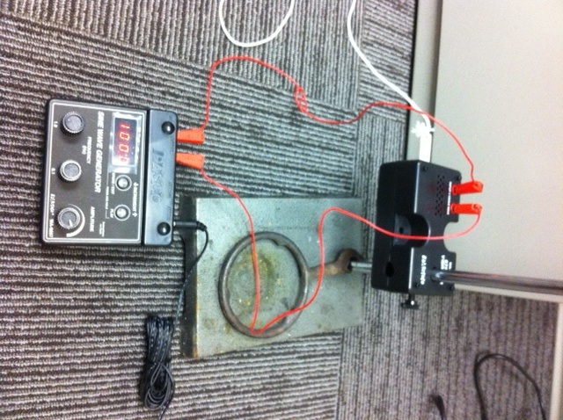
Part 1
- Set your string vibrator and sine wave generator up as shown in the picture above.
- One person should hold the string one meter from the string vibrator making sure that there is tension on the string.
- Turn on the sine wave generator and set the frequency to 140 hertz. The amplitude should be set to halfway.
- Create tension on the string by gently pulling on it until the waves appear.
- Count the number of waves and record in Table 1.

- Increase the frequency by 5 hertz until you reach 170 hertz. Continue to adjust the tension on the string to make waves visible. Record the results in Table 1.

Frequency | Number of Waves | Wavelength Increase or Decrease?
140 Hz
145 Hz
150 Hz
155 Hz
160 Hz
165 Hz
170 Hz

Discussion

- Draw a diagram of a wave. Label the crest, trough, amplitude, and wavelength.

- Draw a diagram of a wave with a greater frequency than the wave you drew in the diagram above.

- During this activity, as the frequency increased, the number of waves ________________________________.

- As the frequency increased, the wavelength _______________________________.

- Using the terms “crest” and “trough,” describe what happens to wave height when the amplitude knob is turned to the right.

